**Documentation for current progress of django web forum application**

Project current structure

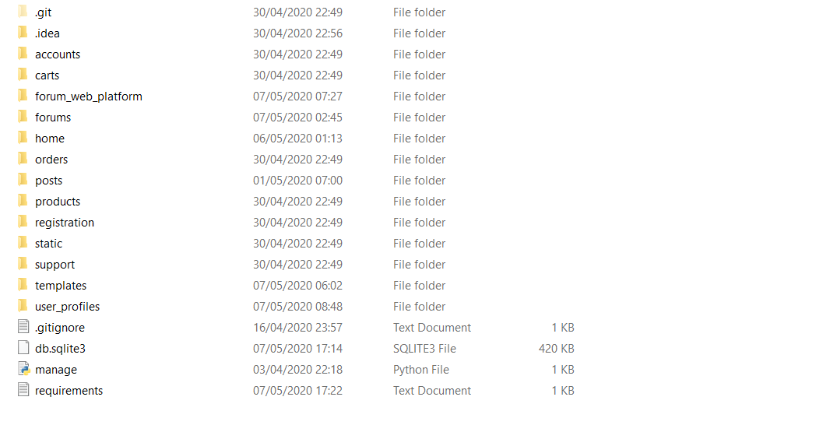

Accounts - for user membership and payment plan (also include database model and schema)

Carts - for checking out after purchase (also include database and view logic)

Forum_web_platform - default project folder consists of settings, timezone middleware for setting current timezone based on the user session. Default url routing file urls.py and asgi and wsgi server configuration

Forums - consists of both Category and Thread database models and view function for performing the business logic for thread, category related views.

Home - consists of the view function for the home page logic

Orders - For user order required for marketplace (includes both database model and view logic)

Products - For product purchase by user in marketplace (includes both database model and view logic)

Registration - for new user registration (includes view logic for user register add user to user database)

Static - Consists of all static, asset and media files used in the project

Support - consists of support database for messages submitted by user and view logic.

Templates - Default base template which include navbar.html, footer.html and base.html

User_profiles - contains the user, user profile, user evaluation models for creating new user profiles using signals when new user registers.

db.sqlite3 - This is the development database for storing project specific data

Manage.py - django project utility for command line interface.

Requirements.txt - list of all python packages and libraries used in the project

Quick setup guide

Read me

This is a forum web application written in python django

The root directory consists of a manage.py file which is the project command utility interface.

To step up the project in a development environment

1. cd to the project root directory (where the manage.py file is located)
2. Run pip install -r requirements.txt
3. Using the current development database the SQLite provide with this project no need to create a new database schema
4. Run python manage.py createsuperuser from the project root directory
5. Run python manage.py runserver from the same project root directory

Setup is completed.